**HyC USD Token**

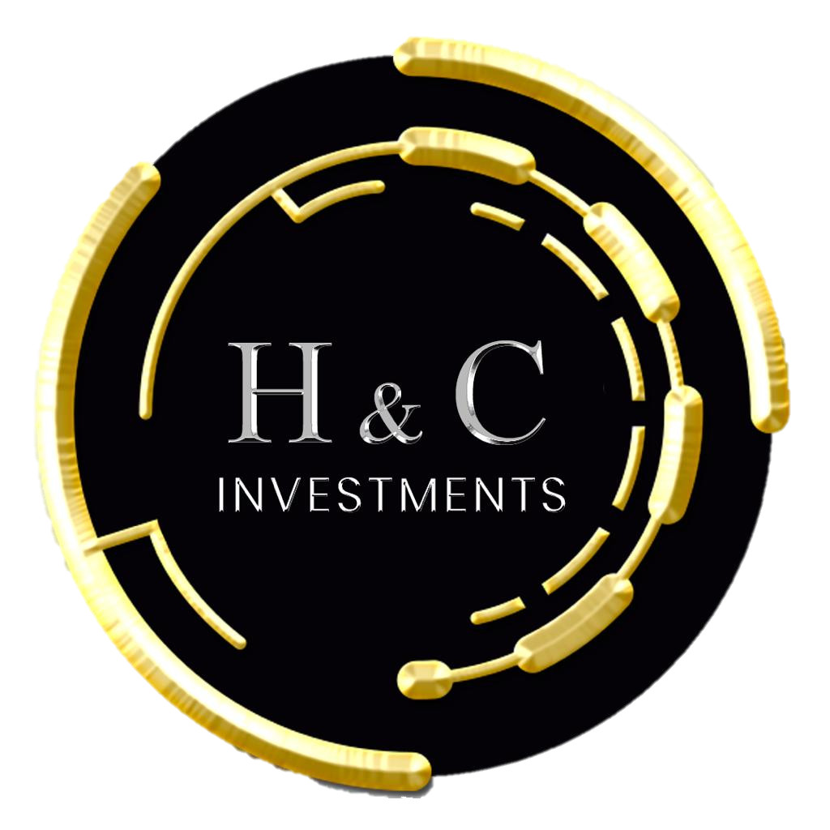

The Token allows HyC Investments investors to have a backing for their investments for the following reasons:

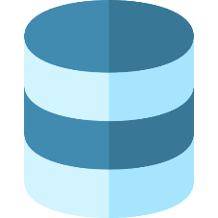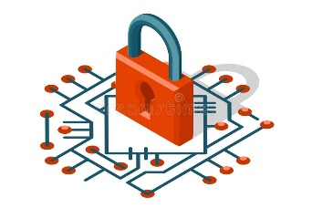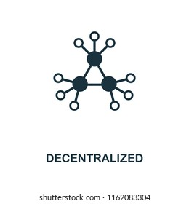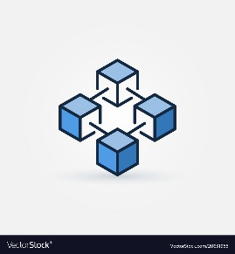

Blockchain Technology Descentralized Secure Backed

**Blockchain Technology:** Created on the OKExChain network which is an open source technology developed by OKEx for the creation of blockchain -based trading applications.

**Decentralized funding:** The OKExChain network is designed to establish a decentralized, secure and efficient architecture that can be used to create a Decentralized Exchange (DEX), with the following features:

* Community-based trading
* Transparent trading rules.
* Allows users to control their own assets.

**Secure:** Allows verification of investment amount in the Metamask Wallet.

**Backed:** Created by means of an IDO that allows transmitting greater confidence to the investor.

**Why choose our token**

**Value:** Our token will initially have parity with USDT and will increase as it is used.

**Compound interest:** Earn compound interest on every investment you make.

**Blocked liquidity:** To guarantee your investment our token is with blocked liquidity.

**In the process of enlistment in Exchanges:** For greater reliability the token is in the process of enlistment in the Coinmarketcap and Coingecko exchanges.

**Non-exchangeable:** The HyC USD token is not exchangeable.

**Roadmap**

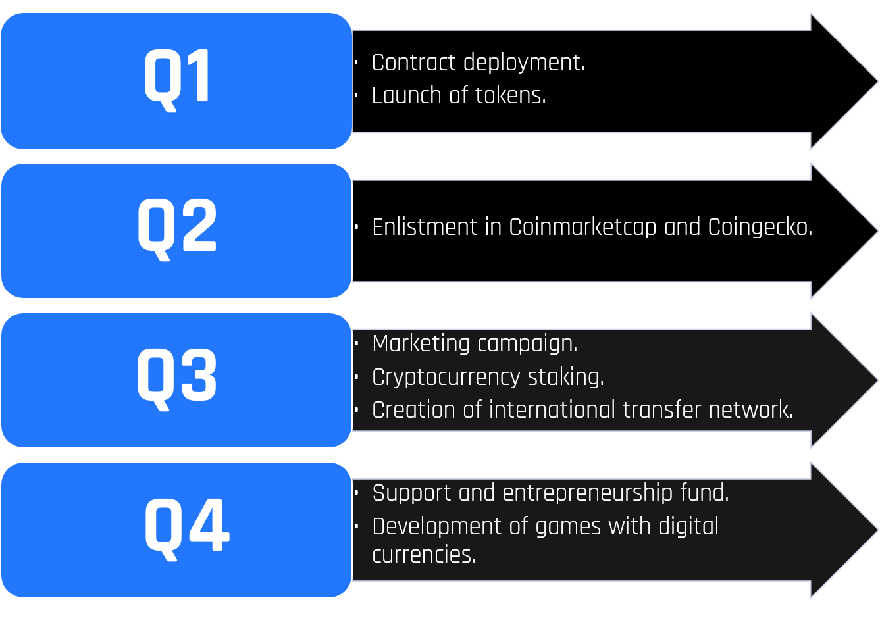

**Availability**

The token is now available on the OKEx platform. This token will serve as a backing for your investment in HyC Investments.

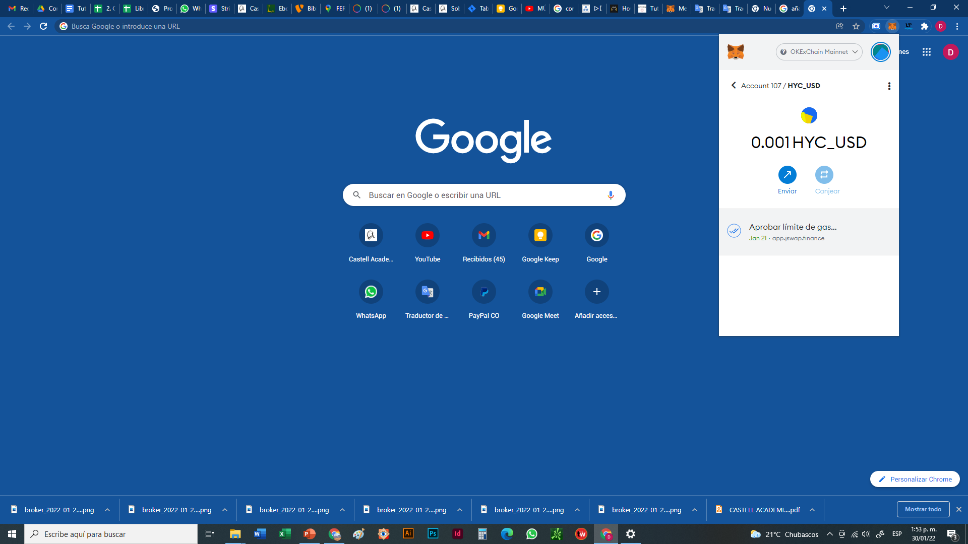

**Investment proposal**

We deliver the equivalent of your investment in the HyC USD token that will function as collateral until the end of your contract, at which time you must return all the HyC USD tokens to get back your initial investment amount.

**Dividends**

The dividends from our main activities, give us a gross profitability of 20% effective monthly on the total capital involved; which given our cooperative nature is distributed in a transparent manner as follows:

* 25% for profitability payments to our investor partners (Equivalent to 5% effective monthly profitability on the invested capital).
* 35% for business expenses.
* 25% to increase the company's equity.
* 15% for research and development.

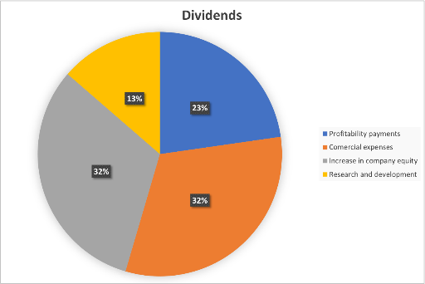

In this way part of the dividends are destined to be prepared for any business opportunity and not depend on a particular niche.

For more information about the whitepaper open the following link:

To download the step-by-step manual to hold your HyC USD token, open the following link: